Image | 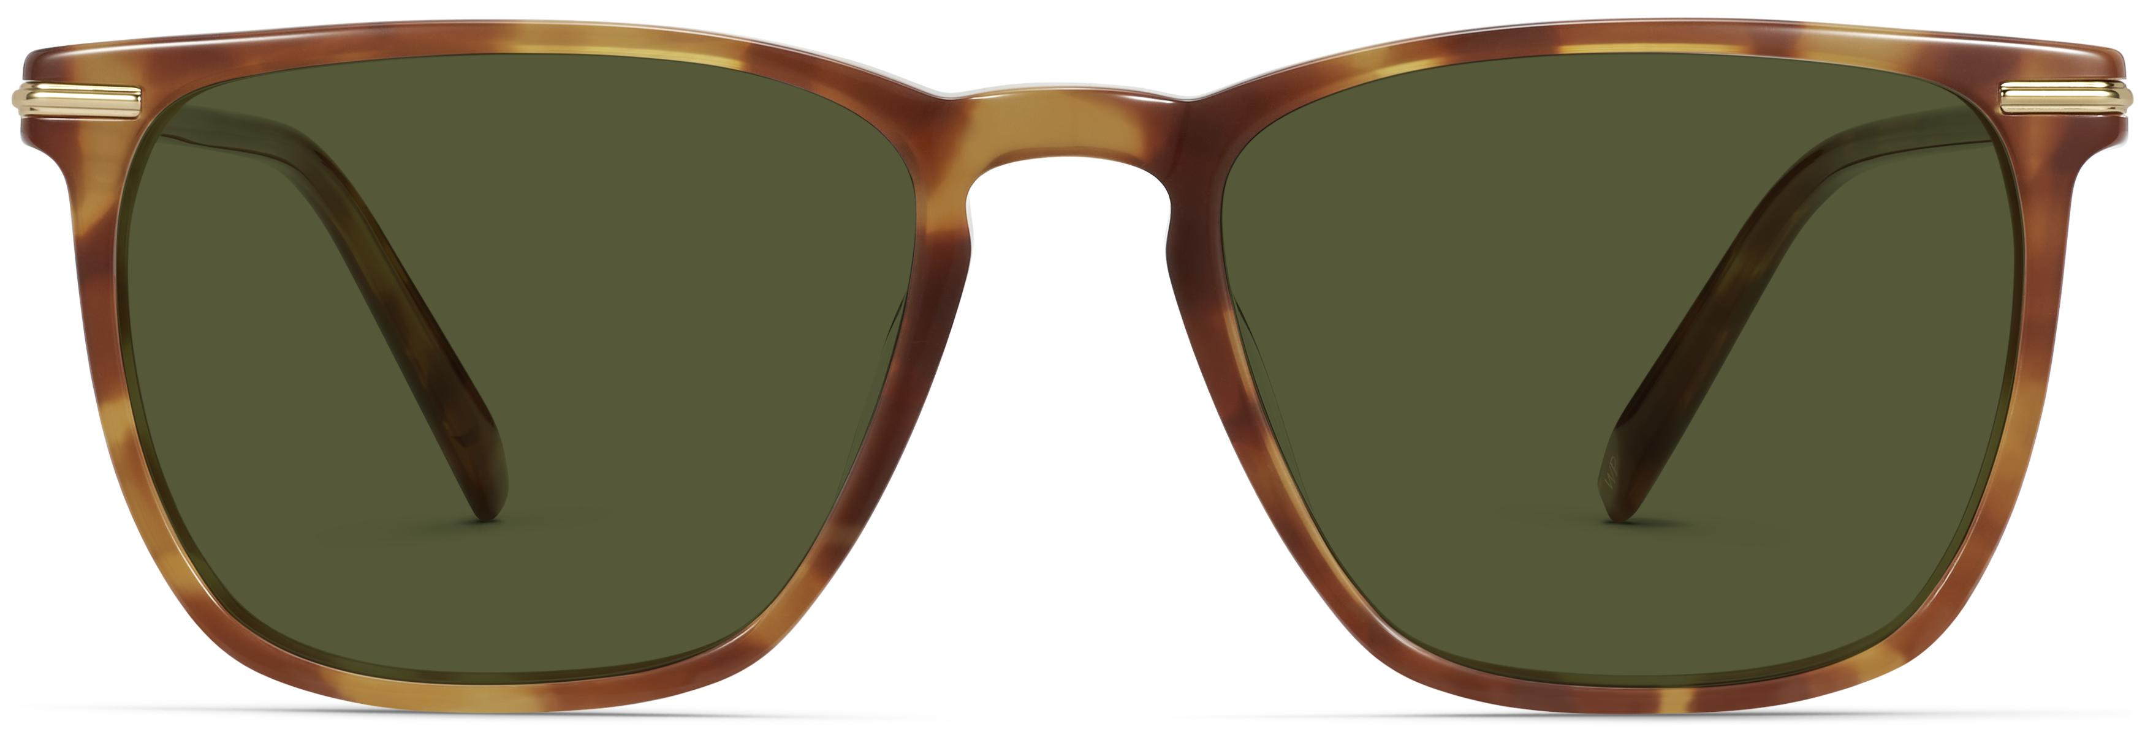
Brand | TOM FORD
Model Name | Sutton
Price | RS 1450
PRODUCT DETAILS

